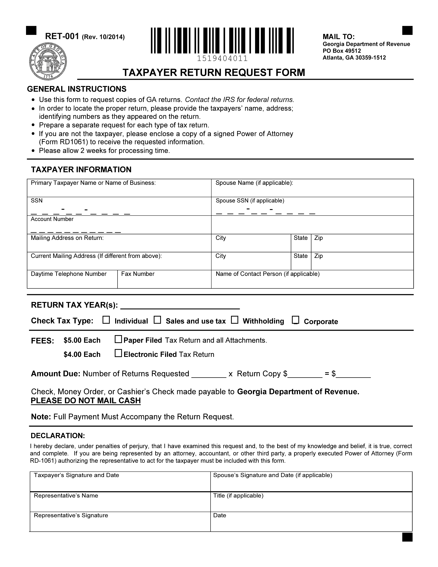
Batman
xxx-xx-5555
Secret Location Under Office Building
Gotham
NJ

